**Compassionate Officer Program (COP)**

**How to create a Needs scenario**

# Steps

Watch the training video.

Set time with Mike Roberts to answer any questions and to grant access to the documents

# ‘**Conversational units’ are the foundation for the basic system.**

The first version of the game will use ‘conversational units’ to manage the conversation. In the long term

we may try and combine several approaches to achieve the best training experience.

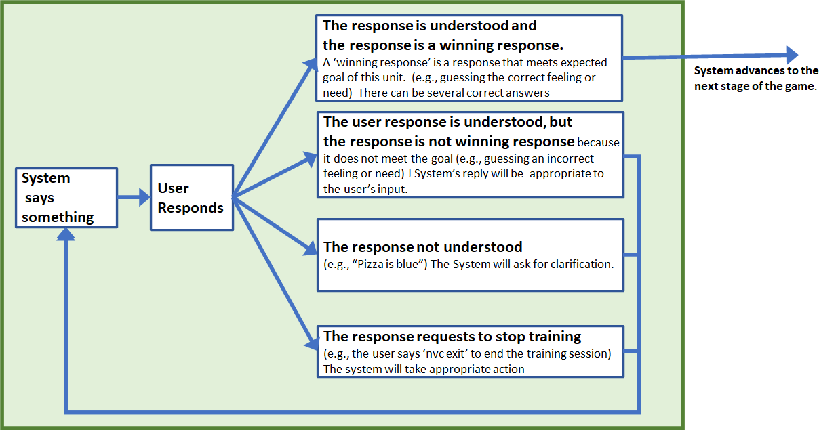

## 

# **How to score NVC points in the game - Options**

**Scoring Model #1 - “The Simple Model” (Easy)**

* Picking any correct feeling/need gives 100 points, which is enough to move to the next stage.
* Picking an incorrect feeling/need has no impact on your score
* Picking 2 incorrect feelings/needs will prompt the system to offer a clue
* Picking 4 incorrect feelings/needs causes system to automatically move on to the next stage

Picking any feeling/need in green will give you the 100 points necessary for the next stage.  
ONLY PICK ON EMOTION AT A TIME, because it is hard to parse 2 emotions.

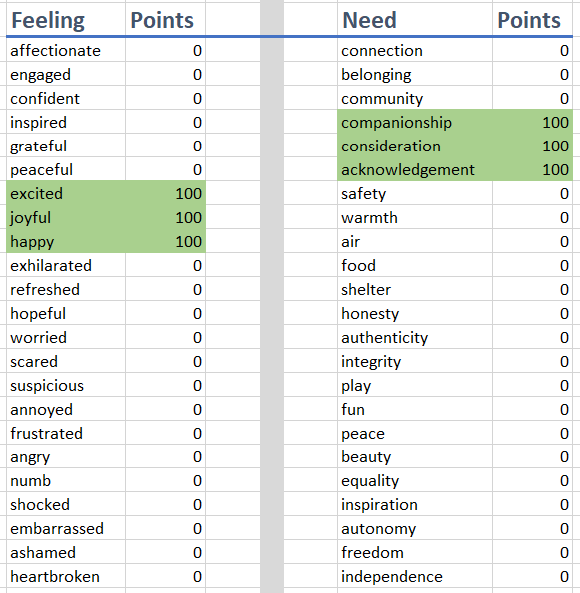

**Scoring Model #2 - “Needs a little empathy”(Medium)**

In this model you will need to identify more than one feeling/need in order to collect points.

* Picking any correct feeling/need gives partial points. (e.g. 35 points) Once you have collected over 100 points, you get to move to the next stage.
* Picking an incorrect feeling/need has no impact on your score
* *Optional: system may offer a clue after X number of incorrect feeling/need guesses*
* *Optional: system to automatically move on to the next stage after Y number of guesses*

Picking several feeling/need in green will give you the 100 points necessary for the next stage.   
ONLY PICK ON EMOTION AT A TIME, because it is hard to parse 2 emotions

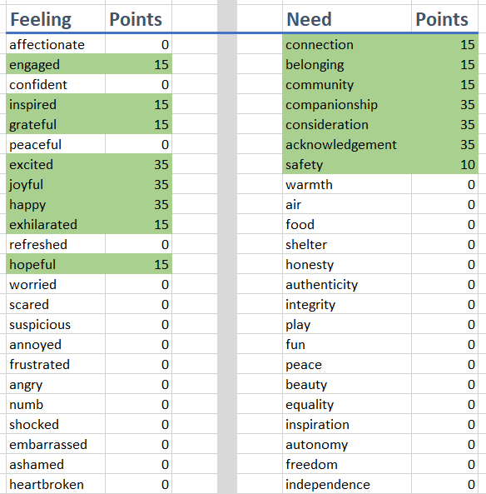

## 

**Scoring Model #3 - “Emotionally fragile” (Hard)**

In this model you will need to identify more than one feeling/need in order to collect points. Picking an incorrect feeling/need will subtract points, which require you to spend more time validating emotions

* Picking any correct feeling/need gives partial points. (e.g. 35 points) Once you have collected over 100 points, you get to move to the next stage.
* Picking an incorrect feeling/need has impact on your score (e.g. -25 points)
* *Optional: system may offer a clue after X number of incorrect feeling/need guesses*
* *Optional: system to automatically move on to the next stage after Y number of guesses*

Picking several feeling/need in green will give you the 100 points necessary for the next stage.   
ONLY PICK ON EMOTION AT A TIME, because it is hard to parse 2 emotions

